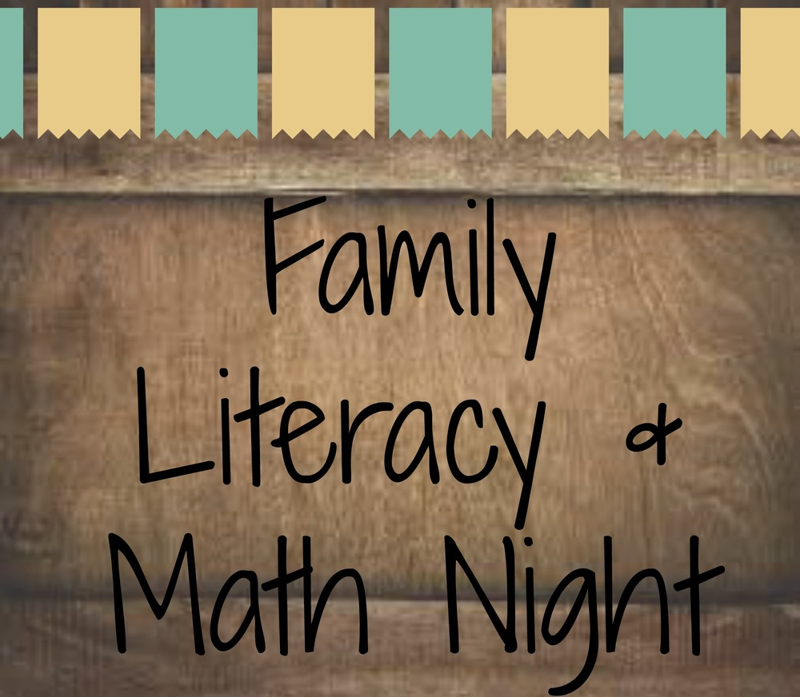

Bryant Middle School
Literacy and Math Night!
Thursday, May 4, 2023
5:30-7:00 pm
Location: Bryant Middle School
Activities Location
Make a bookmark Lobby
Snack Station Lobby
Bingo for Books Room 58
Guess How Many? Raffle! Lobby
360 degree Photo Booth Cafeteria
Math Puzzles and Games Room 42
Versatiles Room 18
Bring a Book-Take a Book Lobby
Word Games Room 15
Conversation Table Lobby
Make A Monoprint Sketchbook Room 52

Bryant Middle School
ليلة القراءة والرياضيات!
الخميس 4 مايو 2023
5:30 - 7:00 مساءً
الموقع: مدرسة براينت

Activities Location
Make a bookmark Lobby المدخل
Snack Station Lobby المدخل
Bingo for Books Room 58 غرفة
Guess How Many? Raffle! Lobby المدخل
360 degree Photo Booth Cafeteria كافتيريا
Math Puzzles and Games Room 42 غرفة
Versatiles Room 18 غرفة
Bring a Book-Take a Book Lobby المدخل
Word Games Room 15 غرفة
Conversation Table Lobby المدخل
Make A Monoprint Sketchbook Room 52 غرفة

